Saurav Shrestha

Organocity

Trader (PHP) Testing

Organocity

# Table of Content:

1. Registration
2. Login
3. Profile
4. Product
5. Discount
6. Shop
7. Dashboard
8. Report
9. Sign out

# Trader (PHP) Testing

1. Registration
   1. With empty fields

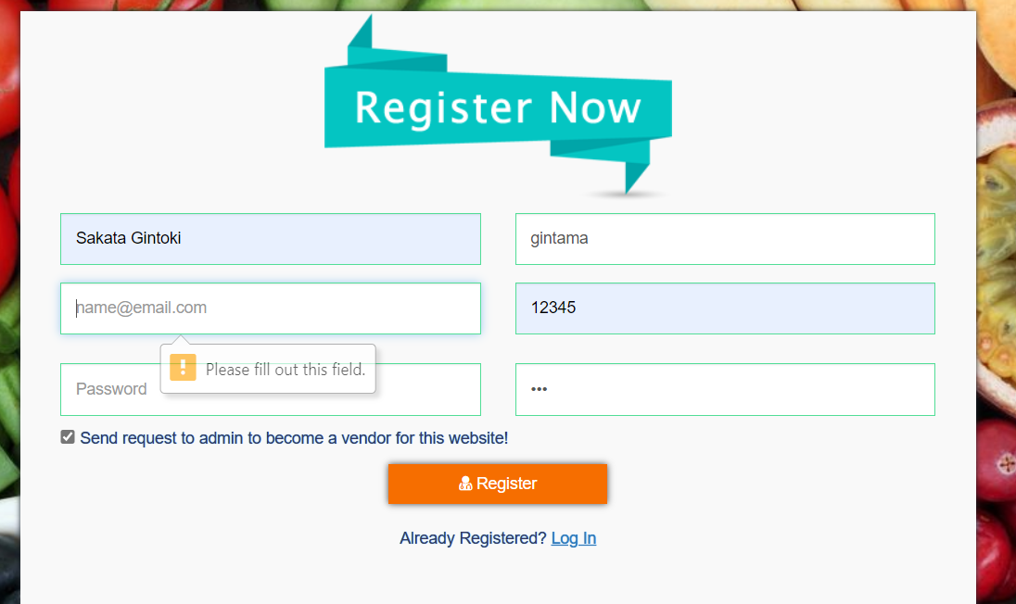

“Error Message is Displayed”

* 1. With invalid credentials

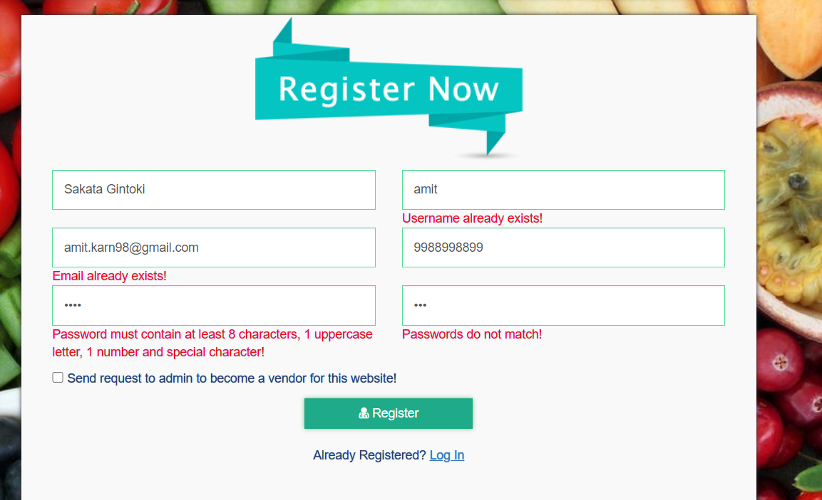

“Error Message is Displayed”

* 1. With valid credentials

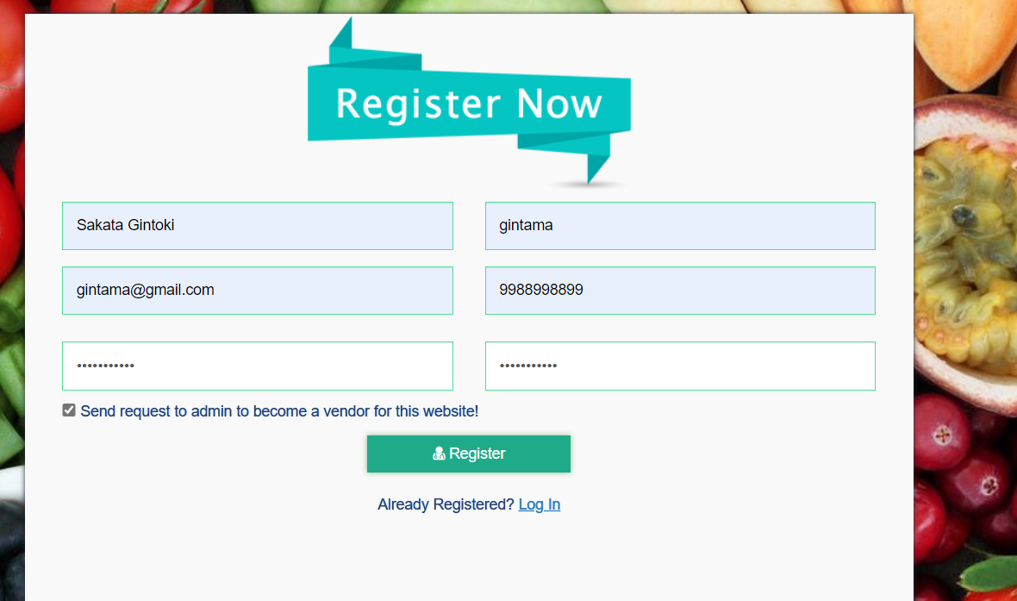

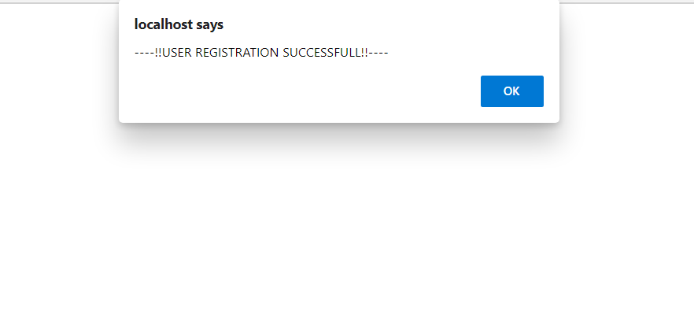

“Trader is logged in successfully”

1. Login
   1. With empty fields

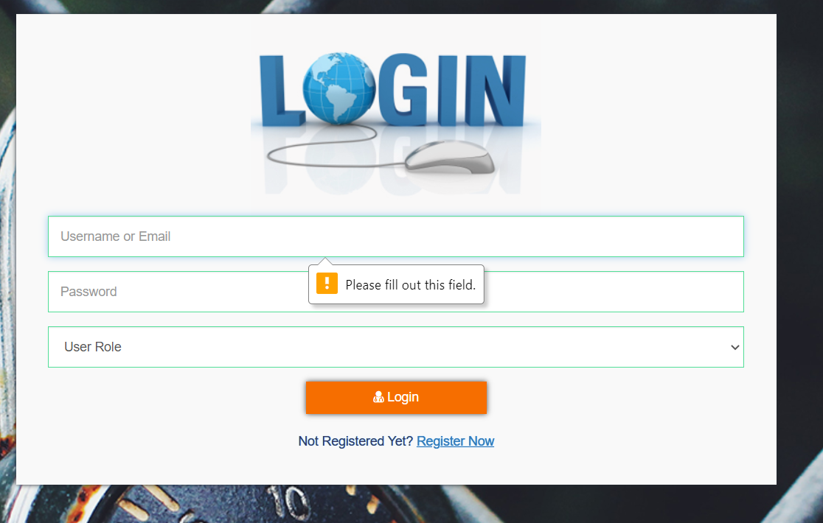

“Error message is displayed”

* 1. With invalid credentials

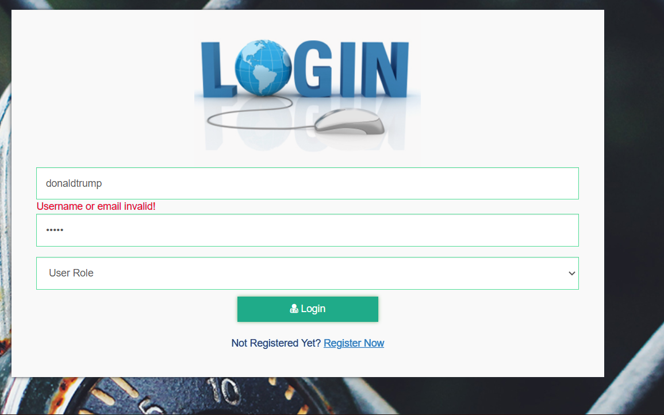

“Error message is displayed”

* 1. With valid credentials

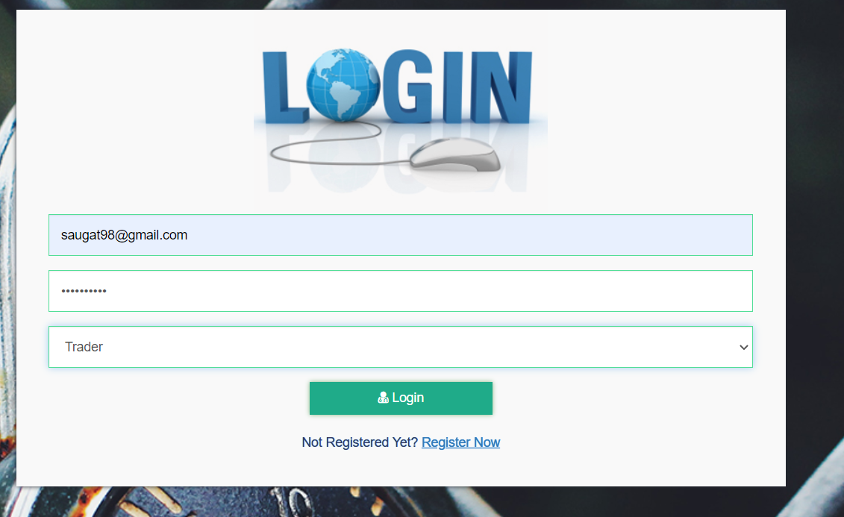

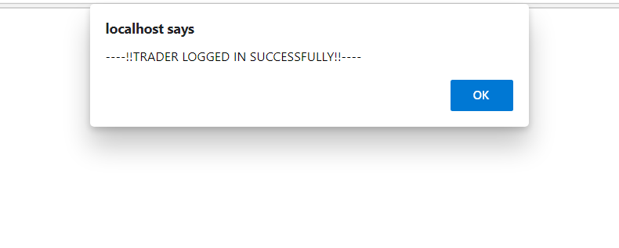

“Error message is displayed”

1. Profile
   1. Can edit profile

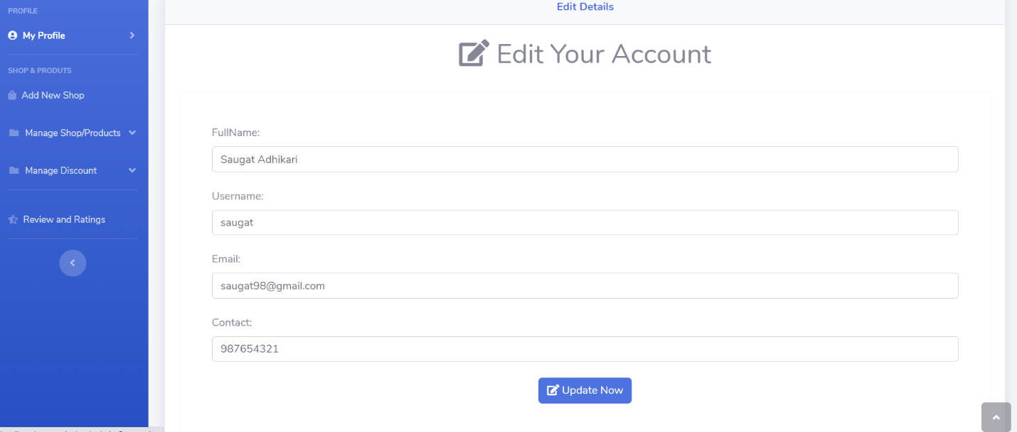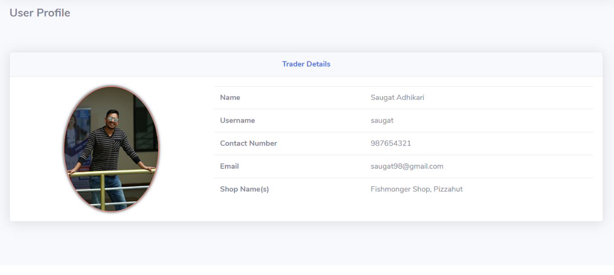

“Profile details gets updated”

* 1. Can upload profile photo

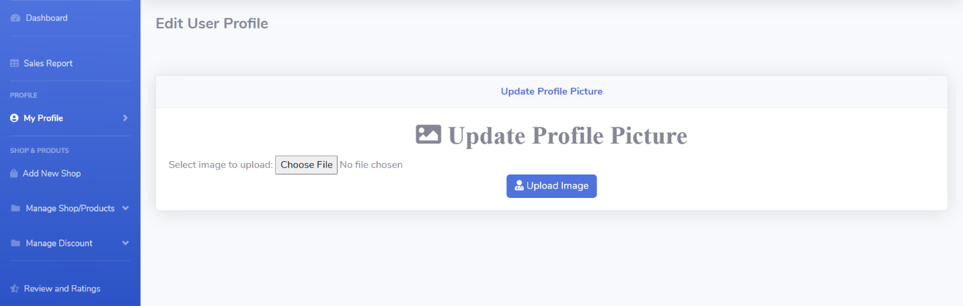

“Profile picture gets uploaded”

1. Product
   1. Add product

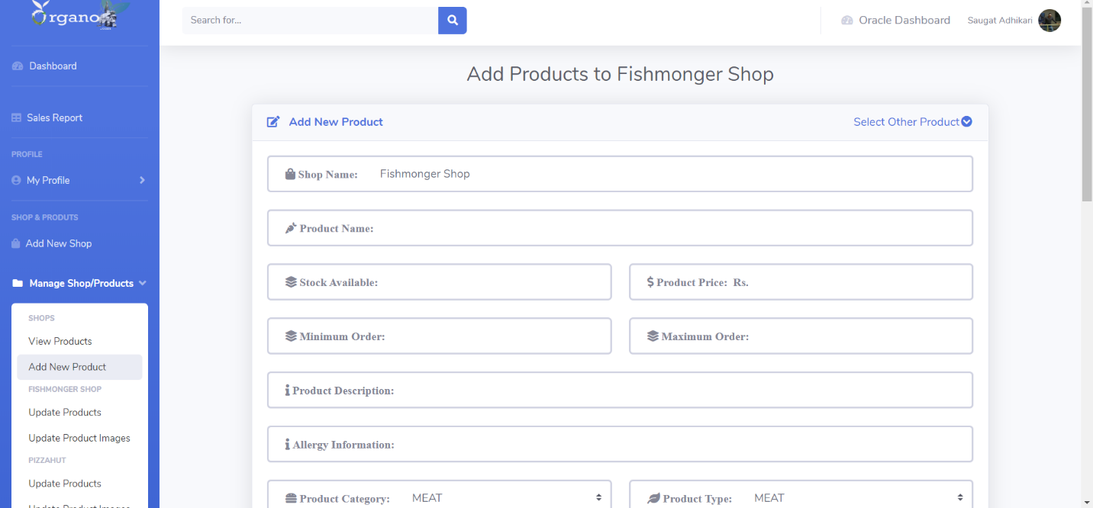

“Product gets added”

* 1. Remove product

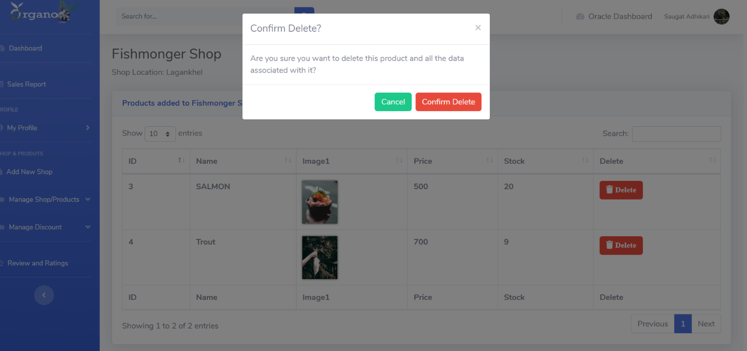

“Products gets removed”

* 1. Edit product details

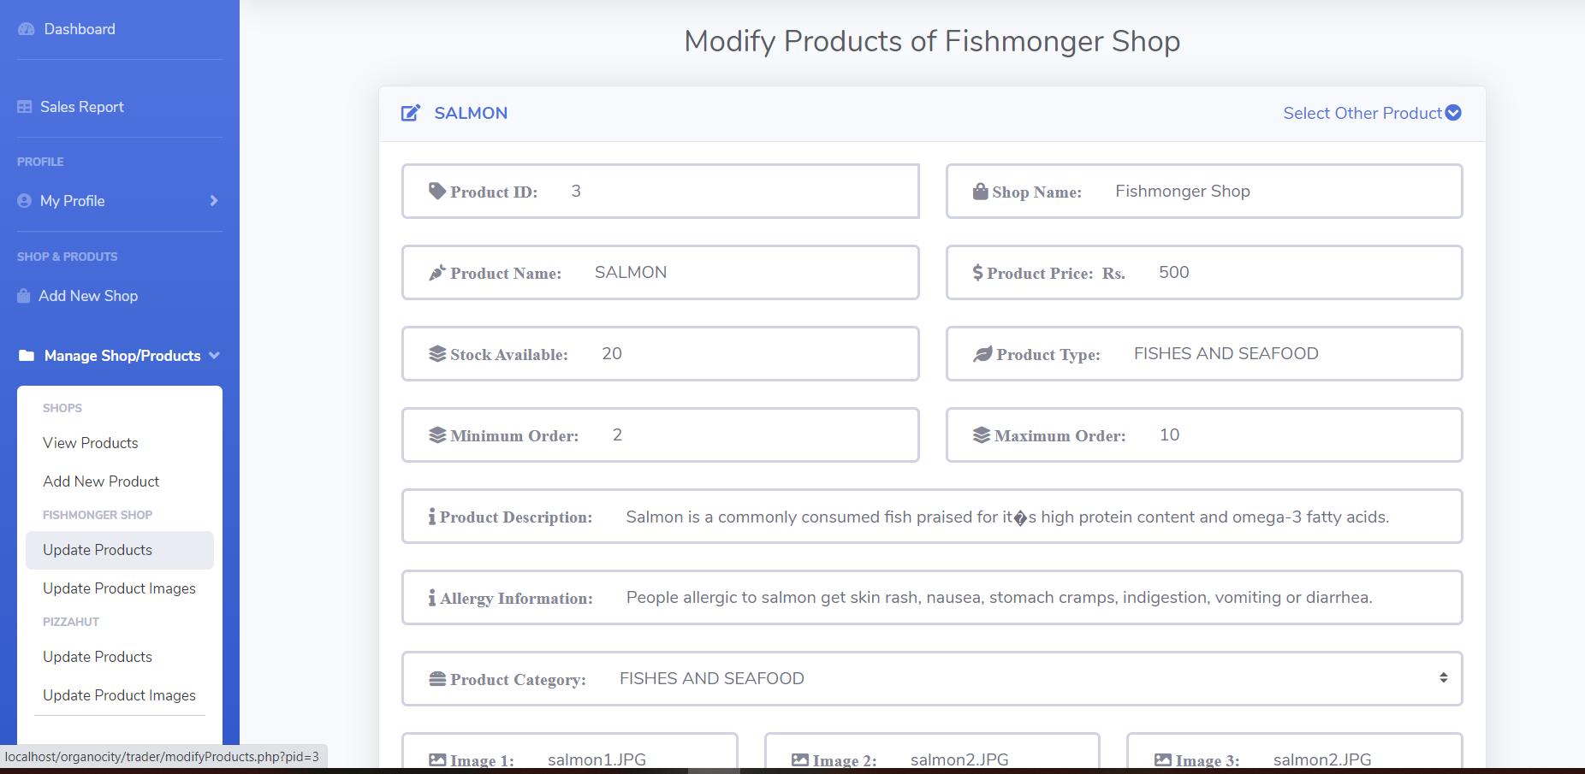

“Products details gets updated”

* 1. Change product images

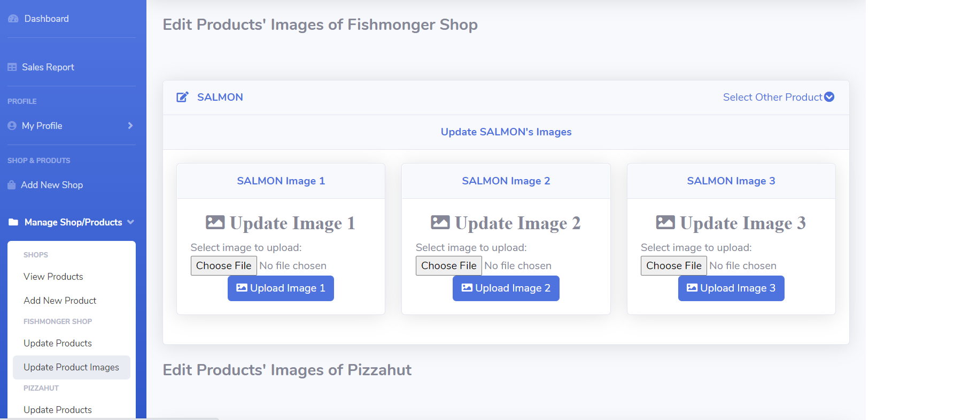

“Product images gets updated”

1. Discount
   1. New discount can be added

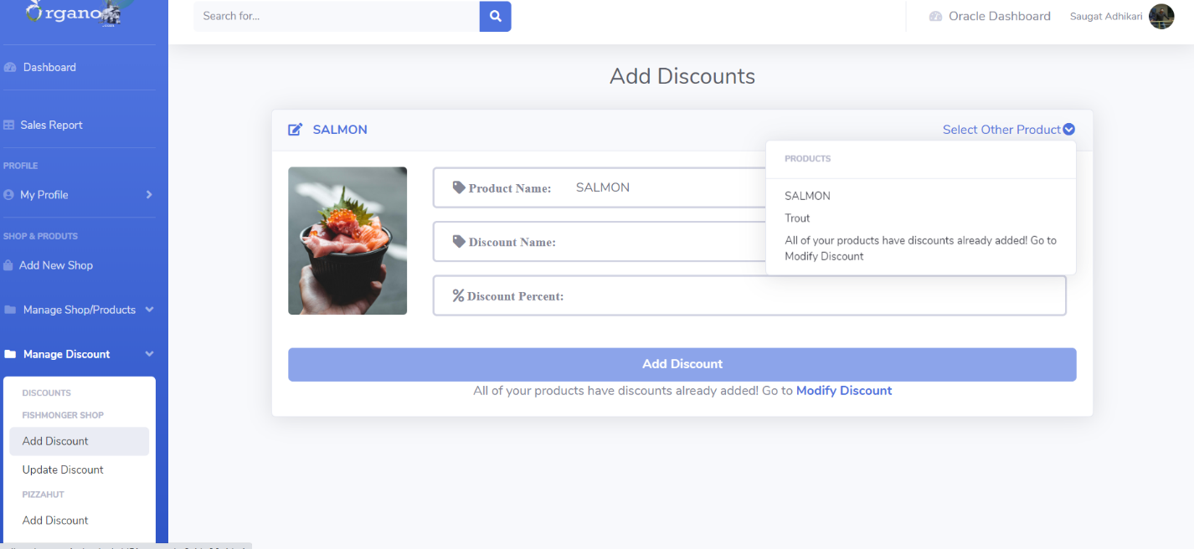

“New discounts are added to the products”

* 1. Existing discounts can be updated

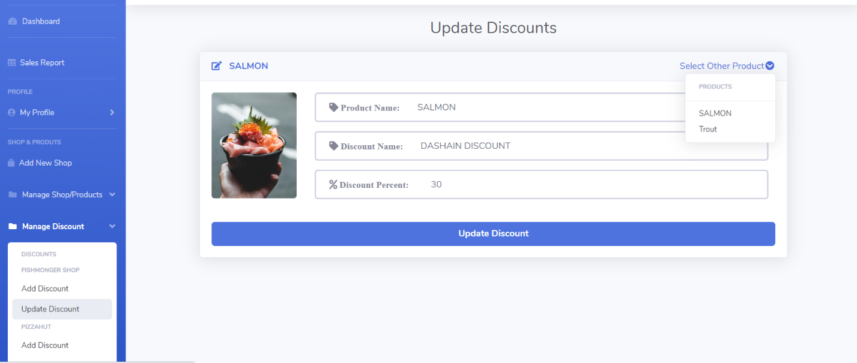

“Names and discount percent can be modified”

* 1. Discounts can be deleted

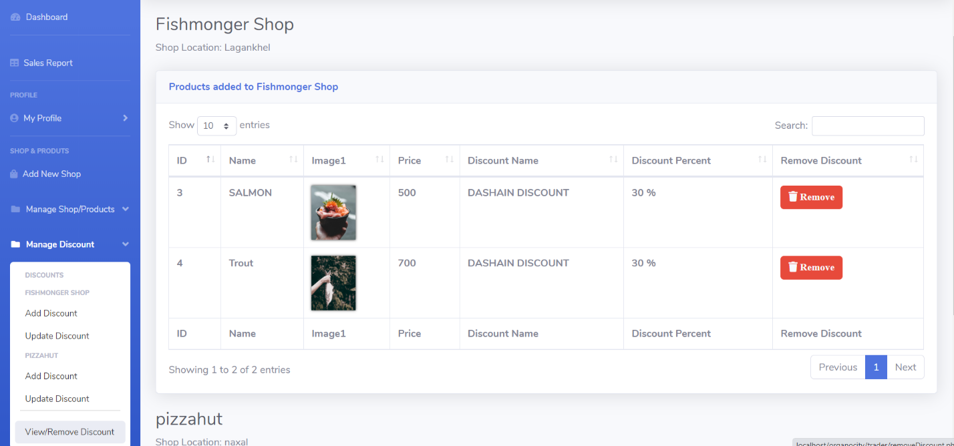

“Discounts given to products can be removed at any time”

1. Shop
   1. New Shops can be added

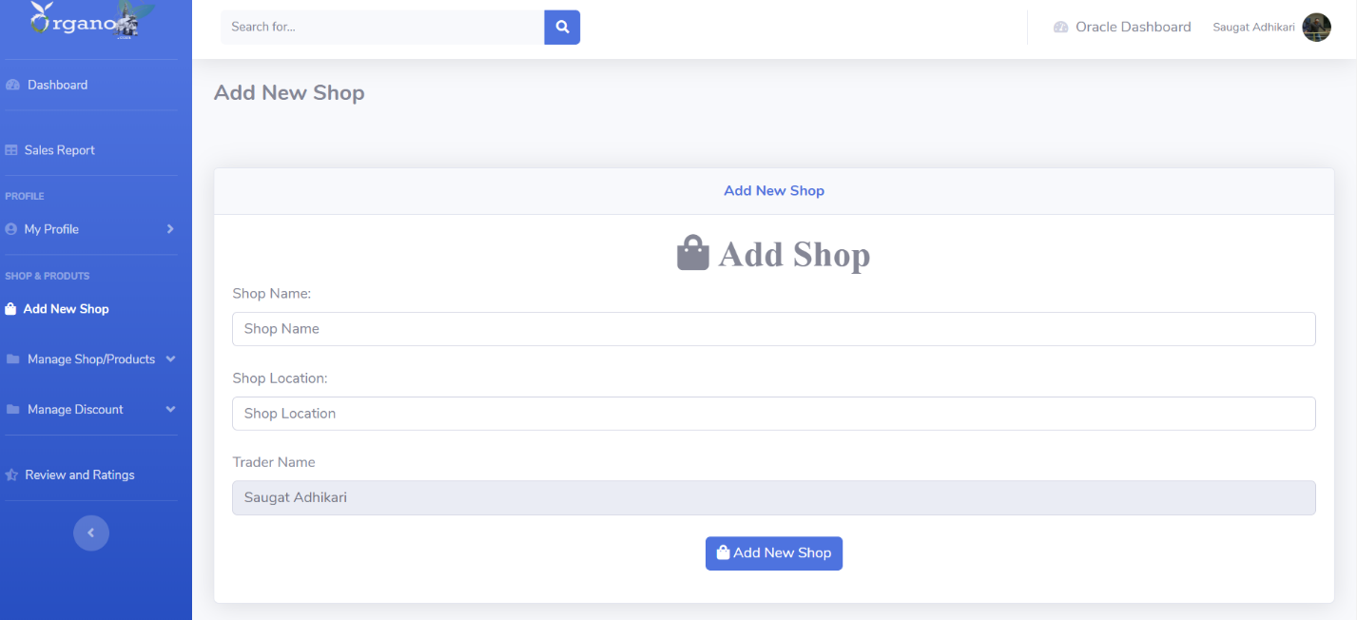

“New Shop is added and linked to the active trader”

1. Dashboard
   1. Dashboard access

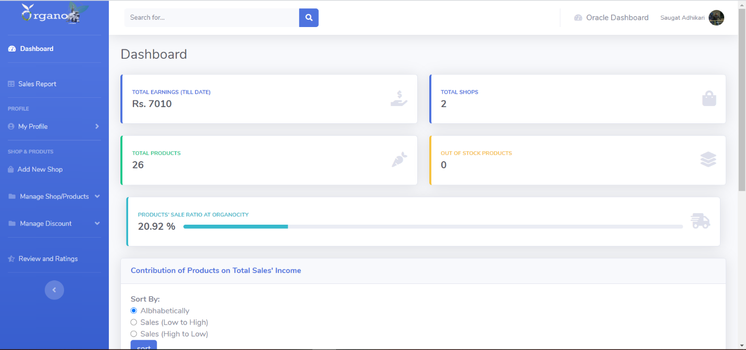

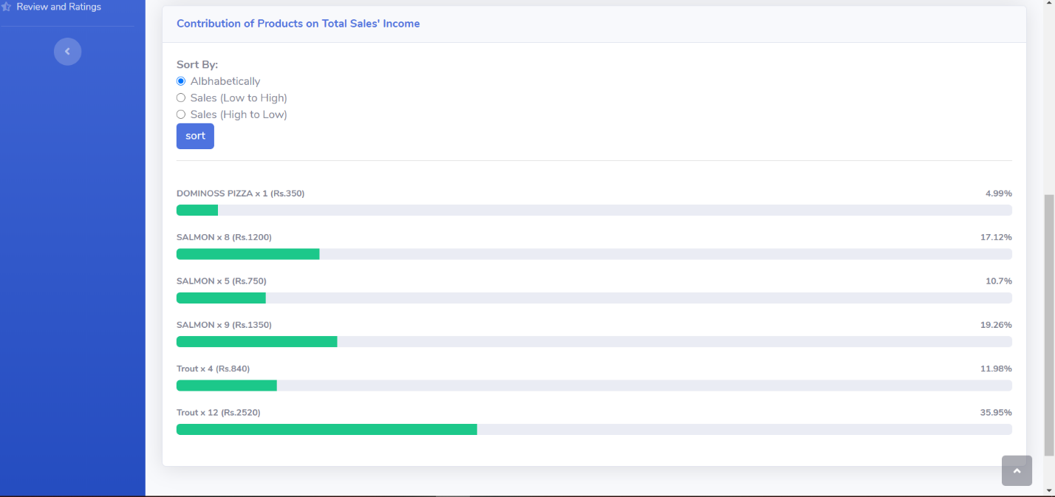

“Trader dashboard”

1. Report
   1. Stock report



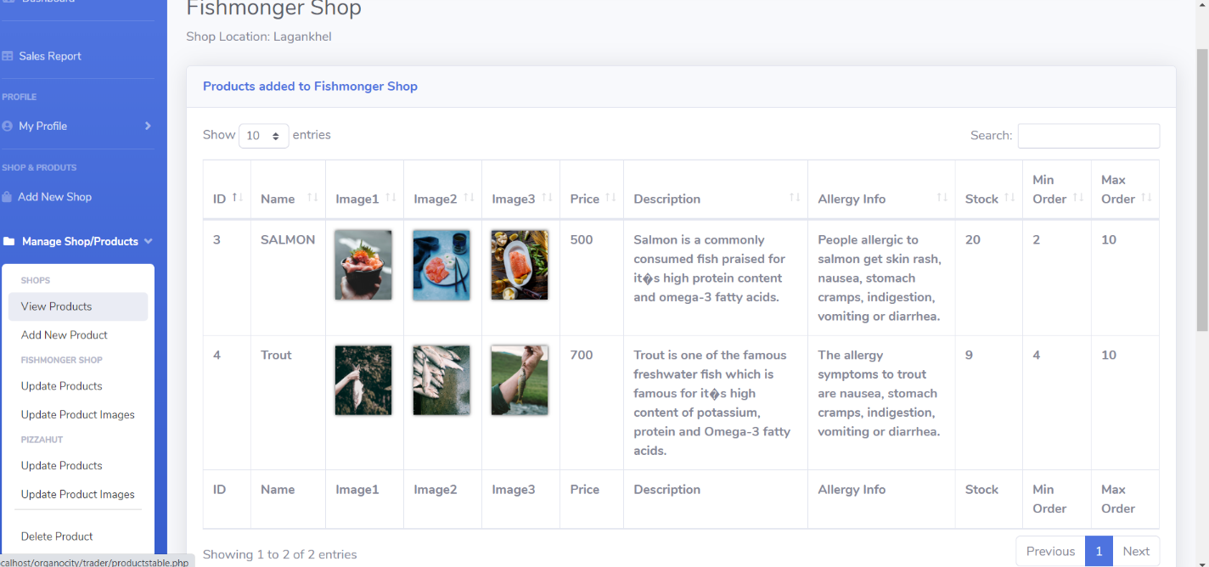

“Traders stock can be viewed from dashboard as well as view products”

* 1. Sales report

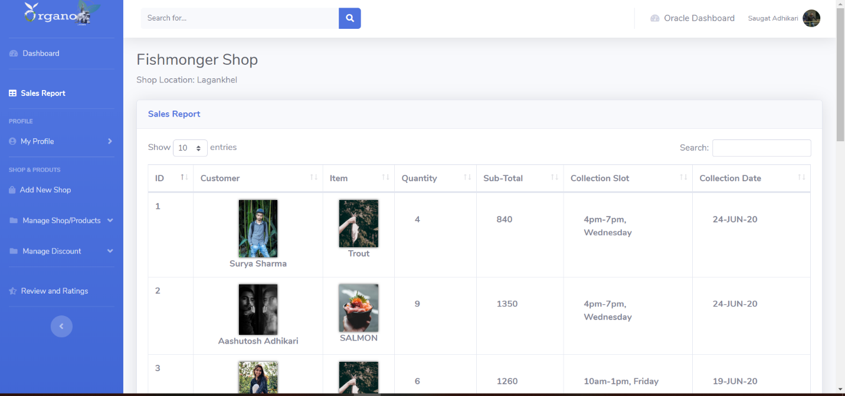

“Sales Report of the product associated with the trader is displayed”

1. Sign out
   1. Trader signs out

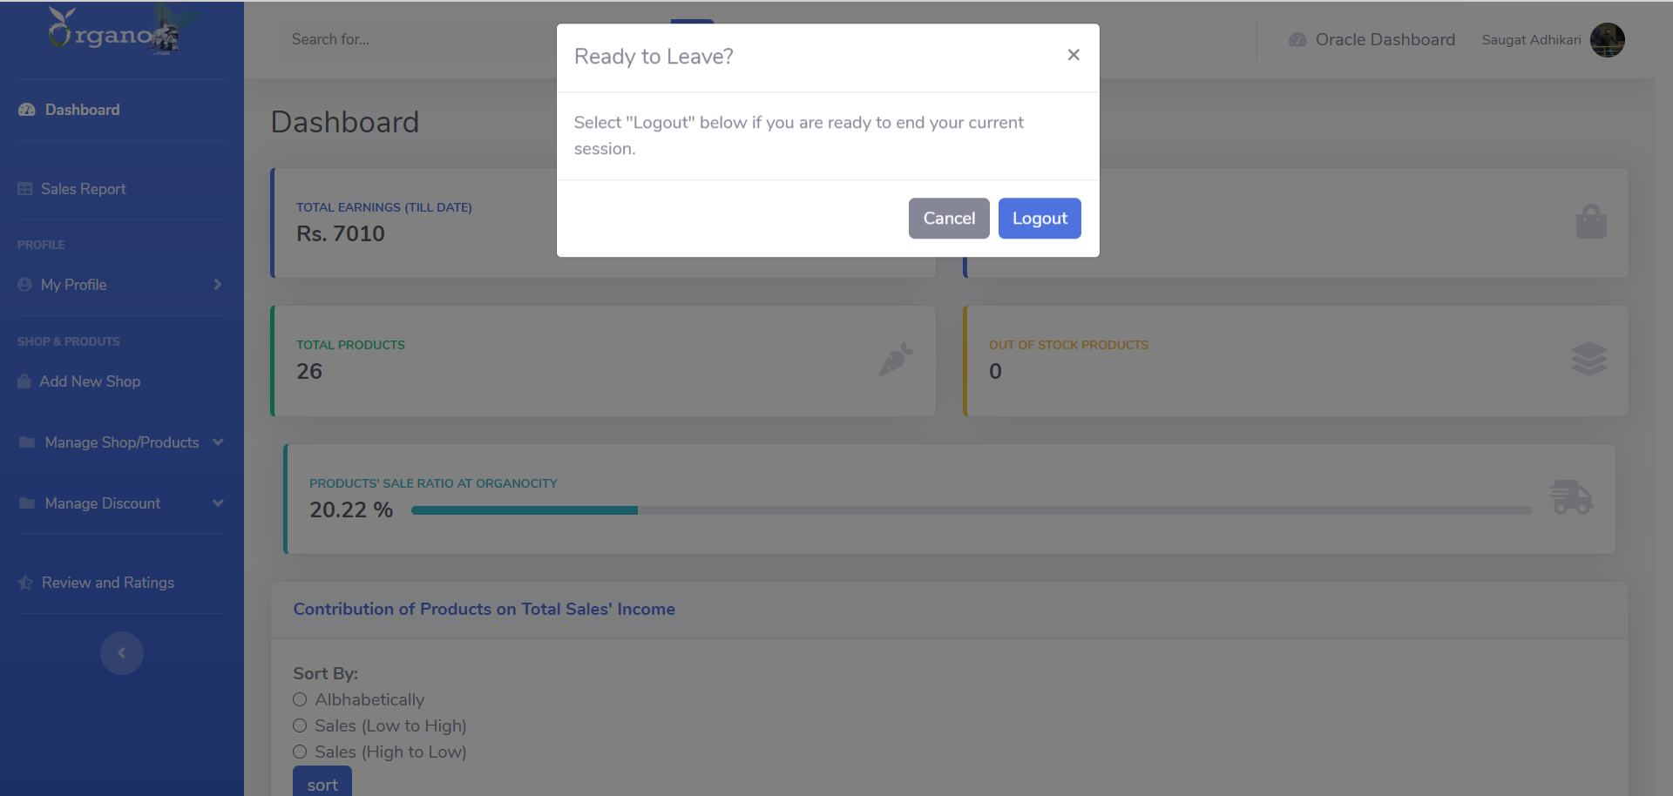

“Trader is logged out”